The Receiving End of the Cooperative Eye: a test by construction
M Schmettow, S. Borsci, __________

Introduction
The human eye region plays a central role in non-verbal communication. Beyond reading emotional states, humans are exceptionally quick and accurate at discerning one another’s gaze direction. The Cooperative Eye Hypothesis (CEH) proposes that this ability evolved alongside the emergence of human hyper-cooperation and altruism. A key anatomical feature supporting CEH is the conspicuous white sclera, which is present in Homo sapiens but absent in all other extant great apes, whose scleras are largely obscured by pigmented conjunctiva (Kobayashi & Kohshima (2001)).
In most great apes, scleral camouflage likely evolved to protect against predators by masking eye position. The CEH, however, interprets the depigmentation of the human sclera as an adaptation for signalling gaze direction, facilitating joint attention in coordinated activities such as hunting and child-rearing. Developmental studies show that even newborns respond to direct gaze and display early forms of gaze following, suggesting an innate cognitive basis for this ability (Farroni et al. (2004)).
Evolutionary theory demands that a mutation must have an immediate reproductive benefit in order to stabilize in a species. The evolution of communicative traits is often difficult to explain because of the inherent reciprocity. A novel signal can only evolve when a matching receiver mechanism exists, and vice versa. While a specialized eye direction detector (EDD) has been proposed even before the CEH (Baron-Cohen (1995)), the conundrum to solve is which of the two emerged first.
Two extreme scenarios are possible: (1) a pre-existing gaze-reading ability in early hominids, which became more effective with scleral depigmentation, or (2) the co-evolution of the white sclera and a new cognitive mechanism for gaze perception. Comparative studies indicate that chimpanzees rely mainly on head orientation rather than eye cues, supporting the idea that human-level gaze reading is a relatively recent adaptation. A reasonable middle ground between these extremes is that early hominids may have possessed a rudimentary visual mechanism for gaze estimation, such that scleral depigmentation had some immediate benefits. Subsequent selective pressure may then have produced a specialized, more effective EDD.
We argue that mutations leading to depigmentation are more likely to happen than mutations producing novel neural pathways. Under this hypothesis, the pre-existence of a rudimentary receiver, as well as the evolution of a specialized EDD are more likely if the signal can be deciphered with general visual-cognitive functioning in humans.
The present work addresses this question in two steps. First, we test the computational simplicity of eye direction reading by introducing the QuadBright method, an eye-tracking algorithm that estimates gaze direction from visible-light brightness patterns using simple statistical learning. We evaluate its accuracy to test whether such a minimalist approach suffices for reliable gaze estimation—thereby “testing CEH by construction.”
Second, we explore the possibility that the QuadBright algorithm approximates what the human cognitive system uses for gaze perception. If so, QuadBright could serve as a candidate computational model for the hypothesized EDD. By comparing machine and human performance under identical visual constraints, we aim to test whether human gaze perception operates within these limits.

The White Sclera in human eyes
Among all extant great apes, only Homo sapiens displays a conspicuous white sclera (Kobayashi & Kohshima (2001)). While other apes possess anatomically white scleras, theirs remain largely concealed by pigmented conjunctiva, creating minimal contrast with the iris and surrounding facial features. This distinction is particularly striking given that maintaining scleral pigmentation requires sustained metabolic investment through complex biosynthetic pathways, while depigmentation reduces energetic costs.
The common explanation for scleral pigmentation follows a camouflage hypothesis (Kobayashi & Kohshima (2001), Wolf et al. (2022)): the high contrast between a dark pupil and white sclera makes an animal more visible to predators and competitors and may even reveal the focus of attention. For species facing predation pressure or intense intraspecific competition, concealing the white sclera provides a clear survival advantage by preventing others from detecting an individual or predicting its next move. The ubiquity of pigmented scleras across great apes indicates strong, persistent selection pressure favoring camouflage despite its energetic costs.
The human pattern represents a remarkable evolutionary reversal. Despite the energetic advantage of reduced pigmentation, the conspicuous white sclera could only have evolved if it provided fitness benefits that outweighed the costs of increased visibility to predators and competitors. The depigmented sclera creates maximum contrast with the iris, making the eye region highly salient even at distance or in peripheral vision. This implies that either the original selection pressure disappeared for humans, or by another selection pressure depigmentation became so advantageous in human ancestors that it overcame the universal great ape pattern of scleral camouflage.

The Cooperative Eye Hypothesis (CEH)
The Cooperative Eye Hypothesis proposes that scleral depigmentation evolved as an adaptation for enhanced gaze signaling, facilitating rapid joint attention in cooperative activities such as coordinated hunting, foraging (Kobayashi & Kohshima (2001)), and child-rearing (@). This hypothesis situates the unique human eye morphology within the broader context of human hyper-sociality and the emergence of unprecedented levels of cooperation among early hominids.
Supporting evidence comes from developmental studies demonstrating that human infants respond to direct gaze and exhibit rudimentary gaze-following behaviors from birth (Farroni et al. (2003), Farroni et al. (2004), Farroni et al. (2007)). These findings suggest that gaze perception operates through innate cognitive mechanisms that are functional in early development, before extensive learning could account for such abilities. The early emergence and universal nature of gaze sensitivity across human populations indicates deep evolutionary roots for this capacity.
Comparative studies with chimpanzees provide additional support for the CEH. Despite their close genetic relationship to humans, chimpanzees rely primarily on head orientation rather than eye cues when interpreting gaze direction (Tomasello et al. (2007)). This finding suggests that sophisticated eye-based gaze reading represents a derived human trait rather than an ancestral great ape characteristic, supporting the hypothesis that enhanced gaze signaling co-evolved with human cooperative behaviors.
The presence of pigmentation in chimpanzees suggests that scleral depigmentation occurred relatively recently in human evolution—likely within the past two million years following divergence from the last common ancestor with chimpanzees. However, this is not decisive, as the same is known about the EDD.
From a biological standpoint, pigmentation pathways are notably complex, involving multiple steps and enzymes—including tyrosinase and its associated proteins (e.g., OCA2, TYRP1, SLC45A2)—each essential for effective melanin synthesis and distribution (Grønskov et al., 2007). Albinism, as a phenotype resulting from mutations in any of these genes, occurs at a relatively high frequency (~1:17,000–20,000 individuals) (Bakker et al., 2022). Several non-lethal mutations are known in humans and apes Dessinioti et al. (2009), Mayhew & Gómez (2015).
Mearing et al. (2022) found that sclera pigmentation varies stronger in anthropoid ape faces than was previously held. In contrast, there is practically no variation in the human sclera
Given the high frequency of non-lethal pigmentation mutations, it is plausible that depigmentation could arise relatively easily in a population. Nevertheless, to become fixed in the population, it had to confer immediate fitness advantages, which requires a receiver mechanism.

The Eye Direction Detector (EDD)
The existence of a specialized receiver represents a necessary corollary to the CEH. For scleral depigmentation to provide fitness benefits, human cognitive architecture must include mechanisms capable of rapidly and accurately extracting gaze direction from visual input. For Baron-Cohen (1995) eye direction detection (EDD) is a pivotal mechanism in his concept of Theory of Mind, marking it as a primarily social cognitive device. The existence of specialized neural networks for gaze processing is supported by neuroimaging studies showing that certain brain regions are preferentially activated when individuals view eye regions or interpret gaze direction (Babinet et al. (2021)).
It is highly unlikely that such a specialized receiver architecture evolved without there being a sender. In contrast to the sender, it is also unlikely that it evolved as a one-point mutation. A possibility is that the white sclera encountered a rudimentary precursor of the EDD. As Laidre & Johnstone (2013) points out, it is a common assumption that “many signals have evolved from what once were cues.”
For the white sclera to become a cue, it had to had possessed visual properties that made it salient for receivers that already existed, which converges with the idea that scleral pigmentation evolved as a camouflage.
Indeed, the high contrast between the white sclera and the dark pupil creates a visually striking pattern that seems to draw “natural” attention. This salience would have made it easier for early humans to detect and interpret eye movements, even in peripheral vision or at a distance.
The salience of a cue in an evolutionary context can be understood in terms of its computational simplicity. Under this view, the likelihood that a matching cognitive mechanism already existed depends largely on how complex this mechanism had to be. Consequently, evolutionary novel receiver mechanisms, such as the EDD, are expected to exhibit computational simplicity while maintaining functional efficiency (Guilford & Dawkins (1991)).
The simplicity requirement is underlined by the fact that gaze reading emerges in human infants before the visual system has fully developed (Babinet et al. (2021)). This suggests that the EDD relies on low-level visual cues that can be processed quickly and efficiently, rather than complex feature extraction or high-resolution image processing.
However, measuring computational simplicity on biological observations bares the risk of circular reasoning, because ease of processing is a consequence of natural selection. In our first study, we test computational simplicity of the white sclera by constructing a technical receiver device using minimal sensory and computational resources. If the minimalist eye tracking device is accurate enough to provide benefits, an upper limit for computational complexity of the signal can be established.

Minimum-Complexity Eye Tracking
If the CEH, extended by the receiver mechanism, is correct, the human eye should be computationally simple to read with visual cues available to a human observer. Most commercial eye-tracking devices use signals that are not available to the human visual system, such as infrared reflections or magnetic fields (Singh & Singh (2012)).
The more recent video-oculographic devices instead use visible light cameras (Zhou & Geng (2004)) and recently gave rise to the development of webcam, smartphone and VR eye tracking (Ciesla & Koziol (2012)). Several algorithms have been developed in this line, often making use of advanced machine learning or computer vision techniques (Krafka et al. (2016)), which often resemble biological visual processing ((Kumar2017?) CHECK). Video-oculographic devices are the only biologically plausible option, because only they work with visible light. Yet, the involved algorithms are computationally complex and demanding, such as filtering, edge detection or neural networks.
As we have established above, the receiver likely is computationally simple, but it must also be robust to resolution and noise constraints, as it is known that humans can still read glance directions in highly degraded images (Yorzinski et al. (2021)).
The visual cortex can approximately be modeled as a deep neural network and one strategy to a minimum complexity is to find the smallest network that still performs well. In this study we employed the opposite strategy, starting from the most simple device imagineable.
We introduce the QuadBright method to eye tracking, which employs the simple fact that the moving pupil produces a change in horizontal and vertical brightness distribution. We chose the most parsimonous way of capturing horizontal and vertical brightness distribution, by splitting the eye image into four quadrants and taking the average brightness in each quadrant, which effectively is an extreme down-sampling to a 2x2 pixel grayscale image. The four brightness values are then used as input to the linear regression model with quadrants NE, SE, SW and NW as predictors for horizontal positions (vertical positions analog):
$$h=β_{h,0}+β_{h,\text{NE}}{\text{Br}}_{\text{NE}}+β_{h,\text{NW}}{\text{Br}}_{\text{NW}}+β_{h,\text{SE}}{\text{Br}}_{\text{SE}}+β_{h,\text{SW}}{\text{Br}}_{\text{SW}}$$

Study 1: Accuracy of QuadBright eye tracking
The first study was conducted to evaluate the accuracy of the QuadBright algorithm. The algorithm was tested on a 36 participants, who were asked to glance at an orange target on a white background, moving in a random pattern between 24 positions in a six-by-four grid.

Methods

YET Zero implementation
To test the QuadBright algorithm, a simple eye tracking device was constructed, called Yet Zero (YET = Yet is your Eye Tracker). An important consideration for the physical design of the eye tracking device is a small footprint of the camera to minimize obstruction of the field of view [FIG]. In contrast, the resolution of the camera barely matters, as QuadBright essentially compresses the input into a four pixel frame. The choice fell on a commercially available USB endoscope camera with a native resolution of 640x480 at 24Hz refresh rate and an AppoTech AX2311 video controller. With a diameter of 5.5mm this camera creates very little obstruction when mounted in the visual field and the six dimmable LED lights provide a stable light source for better accuracy. A simple 3D-printed socket was created to be able to glue the camera to a stick, which in turn was connected to an improvised head mount, using a headphone (Figure 1).
The YET Zero application was written in Python, using PyGame for the GUI and basic image processing routines from OpenCV (Bradski, 2000). The regression model was implemented using the Scikit-learn library (Pedregosa et al., 2011). A calibration phase trains the model with data obtained on nine initial calibration points. To account for small shifts between trials, single-point quick calibrations are performed to realign the parameters $β_{h,0}$ and $β_{v,0}$.
The first iteration of the system was very susceptible to changes in computer screen brightness introduced by the presented stimuli. While the best solution is to use a frontal brightness sensor and extend the model accordingly, as a quick fix the quick calibration was augmented with a highly degraded preview of the next stimulus, just enough to keep the brightness level stable between calibration and trials.
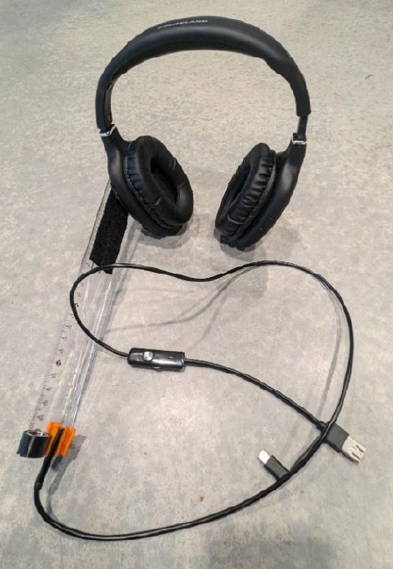
(a) Headmount with camera

Figure 1:  YET Zero prototype assembled from a USB endoscope camera, a ruler, a headphone and a kitchen roll as headrest (Bender & Schmettow, 2024).

Experimental Design
The experiment was carried out with the YET Zero system A headmount was constructed from a headphone and a kitchen paper roll was used as a chin rest. Participants were seated in 45cm viewing distance using a 16:9 screen with a 41cm diagonal. The experiment consisted of 24 trials per condition. The target moved in a random pattern between 24 positions on the screen. The participants were asked to follow the target with their eyes and press a button. The QuadBright algorithm tracked their eye movements and the accuracy of the algorithm was measured by calculating the angular error of estimated eye positions from the true target position.
The original experiment tested three lighting conditions (visible, infrared, no light), as well as consistent/inconsistent screen brightness levels at quick calibration. As expected, inconsistent brightness levels led to a strong decline in accuracy, whereas the light source conditions differed very little. For the analysis here, data from inconsistent background brightness was discarded and the lighting conditions were pooled. Full details of the experiment can be obtained from Bender & Schmettow (2024).

Sample
Twenty-four participants were recruited using convenience sampling. Participants with any form of sight corrections were excluded from the study.

Data Analysis
The effectiveness of the Quadbright method was measured as degree errors between real target position and measured position. From the original experiment only the conditions with a white calibration background was used, resulting in 464499 observations from 24 participants. In order to remove movement artifacts the first and last 500ms where removed and to make the data set more amenable the average over four consecutive frames was taken, resulting in 82445 observations. A multilevel generalized linear model with a log-normal error distribution and log-link was then used to analyze the data. The dependent variable was the angular error in degrees. Target x- and y-positions were used as predictors in a second degree polynomial term to account for increasing errors towards the extremes. The model was fitted using the brms package (Bürkner, 2018, version 2.22.0) in R (R Core Team, 2025, version 4.5.1).

Results
Figure 2 shows the distribution of degree errors across all trials and participants. The distribution is right-skewed, with a long thin tail of extreme errors. The 95% quantile (red line) indicates that most errors are below 10.7 degree. However, this is not evenly distributed across the field, as the error is lowest in the center region and increasing towards the edges (?@fig-error-by-target).
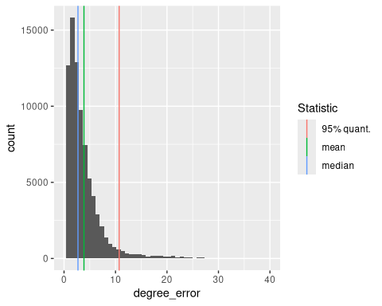
Figure 2: Distribution of degree errors across all trials and participants. Vertical lines indicate the mean (green), median (blue) and 95% quantile (red). Note the logarithmic scale on the x-axis.
Table 1: Coefficient estimates with 95% credibility limits
fixef | center | lower | upper
Intercept | 0.9747846 | 0.8649661 | 1.086635
x_linear | -44.9754207 | -56.2756099 | -33.438458
x_square | 79.9914917 | 73.5592257 | 86.421888
y_linear | -15.7894438 | -24.5453695 | -7.028243
y_square | 37.0874602 | 32.5532476 | 41.753883

The model predicts the degree error in the center of the screen to be 0.97 degree, with a high level of certainty (Table 1). The square terms for both axis are positive and prominent, which means that the error increases towards extreme positions. The linear terms are both negative, which means that the point of optimal accuracy is not in the center, but slightly up and mount-side, with the largest error in the upper nasal corner.
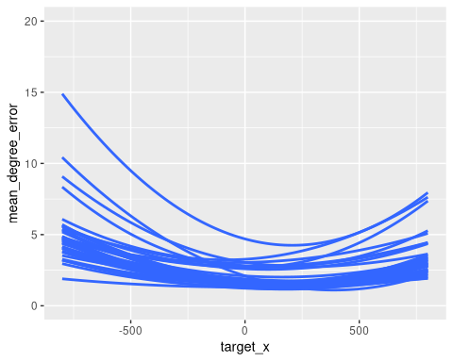  (a) Horizontal error | 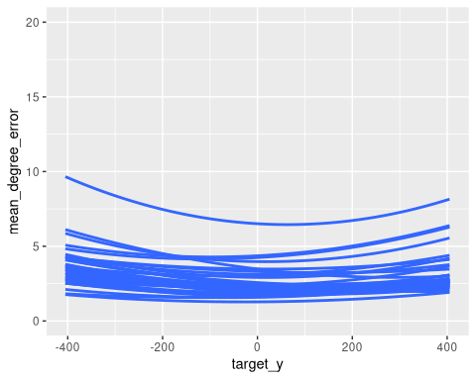  (b) Vertical error
Figure 3: Predicted degree error by target position and participant. Points show center estimate per trial with LOESS lines for interpolation.
Figure 3 shows the fitted degree errors per participant. While the curvature is rather similar, there appears to be individual differences in the overall level. In the vast majority of of participants, the error is below 5 degree for most of the range.

Conclusion
Eye tracking using the Quadbright algorithm typically produces accuracy in the range of 2-5 degree error. This is a magnitude above what is achieved by commercial eye tracking devices using corneal reflections (e.g. Pastel et al. (2021)), but in the same range as other video-oculographic devices (Heck et al. (2023)). In the study of Gale & Monk (2000) similar levels of accuracy were observed on participants when they judged glance directions from eye and head positions. Another similarity is the effect of eccentricity on accuracy, which has been observed for human participants by Loomis et al. (2008). Altogether, the Quadbright device qualifies as a candidate model for human eye direction reading.

Study 2: Human glance perception with QuadBright information
The second study aimed at the possibility that human eye direction reading uses a device, operating similar to Quadbright. As we have argued in [XREF], two possibilities exist: One receiver exists that existed before the white sclera and has possibly gradually evolved since then. Or a primitive receiver created the initial fitness advantage, on which the evolution of a second, more specialized receiver thrived.
A gaze reading experiment was constructed, where accuracy was measured with eye regions reduced to four brightness levels against a control condition. To approximate the depth of processing in both conditions, exposure times were varied from 70 milliseconds to one second. If humans can read glance directions equally well in both conditions, we can assume that there is only one receiver mechanism, which uses only brightness differences. If participants perform worse in the QuadBright condition, this would suggest that two different mechanisms exist, one using low-level brightness cues, and another more specialized mechanism using high-level features. A problematic outcome of the experiment would be if participants cannot read the Quadbright condition at all. In this case, we have no possibility to decide whether a progenitor receiver exists, or whether this just uses a mechanism yet unknown.

Methods

Experimental design
In this experiment, participants see a frontal face glancing at the hours positions on a clock face (Figure 4) and are asked to read the correct hour position. The Quadbright condition was created by masking the eyeball region by a two-by-two grid of brightness levels. A Python script using the OpenCV library (Bradski, 2000) was used to automate the task (Großerichter & Schmettow, 2025). Exposure times varied in five steps (70, 140, 400, 600 and 1000 milliseconds).
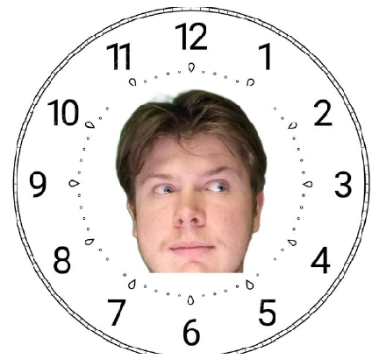
(a) Control condition

Figure 4: 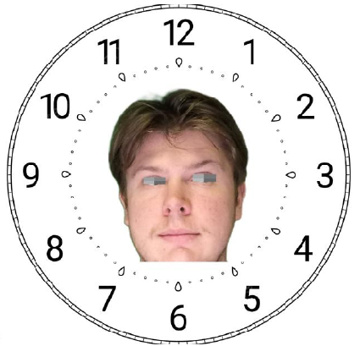 Example stimuli image with eye direction at 3 o’clock position (Hölter & Schmettow, 2025, with permission)

Sample
A sample of 43 participants was collected via convenience sampling with 20 female, 23 male, 18 to 70 years with an average age of 34.2 years). The study was approved by the Humannities & Social Sciences ethics committee of the University of Twente under the number 250623. All participants provided informed consent prior to participation.

Data analysis
The outcome variable is the deviations between true and reported hour positions, resulting in a discrete outcome. A two-factorial predictor term with conditional effects for exposure time and condition (Control, Quadbright) was used on population-level (fixed effects), as well as on Stimulus and Participant level (random effects). Stairways coding was used on factor Exposure, resulting in coefficients that describe the difference to the previous level.
To account for over-dispersion, a negative-binomial outcome distribution with logarithm link function was tried first, but the extremely large reciprocal dispersion parameter suggested that the data is not over-dispersed and the Poisson family was used. Model selection using Loo information criteria was used to explore alternative models. All computations were carried out using the Brms package (Bürkner, 2018, version 2.22.0) package in R (R Core Team, 2025, version 4.5.1).

Results
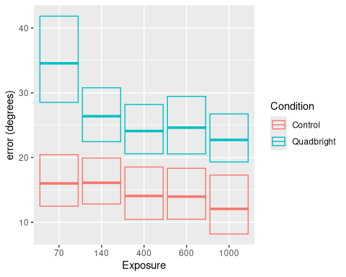
Figure 5: Estimated degree error by condition and exposure time with group-level 95% credibility intervals.
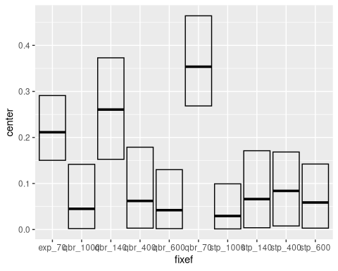
Figure 6: Variance component analysis on the full conditional model.
Starting point of the evaluation is a full conditional model, allowing all levels to align freely. Figure 5 shows a clear separation between conditions, with consistently better performance in Control. However, starting at 400ms the two conditions seem to run in parallel. A variance component analysis revealed that these levels also explain most of the inter-individual variance.
Participant-level variance component analysis shows that variation is strongest in the default condition (70ms, control) and the respective conditional effect, but also the conditional effect at 140ms. All other components are negligible. In consequence, a reduced model with conditional effects only for 70ms and 140ms exposure was fitted. Subsequently, LOO IC formally confirmed that the reduced model has superior predictive value ($31985<32316$).
Table 2
Population-level effect | center | 2.5% CrI | 97.5% CrI
Control_70 | 16.9% | 13.9% | 20.4%
qbr_70 | 204.5% | 178.3% | 234.1%
exp_140 | 90.3% | 71.1% | 115%
qbr_140 | 84.6% | 62.6% | 115.6%
exp_400 | 92% | 86.1% | 98.5%
exp_600 | 100.7% | 95.3% | 106.2%
exp_1000 | 92.9% | 87.8% | 98.2%

In the default condition (Control, 70ms) the average angular error is 16.9°, with some uncertainty (Table 2), whereas the Quadbright condition produced error around twice as large. There appears to be a small improvement at 140ms, which is more pronounced for Quadbright (90.3% x 84.6%), but this is far from being certain. At 400ms errors drop to around 92% (conditions combined), which may be a little more or less, but it is credible on 95% level. At 600ms average angular error remains stable, before taking another drop by around 92.9%, which is sufficiently certain.
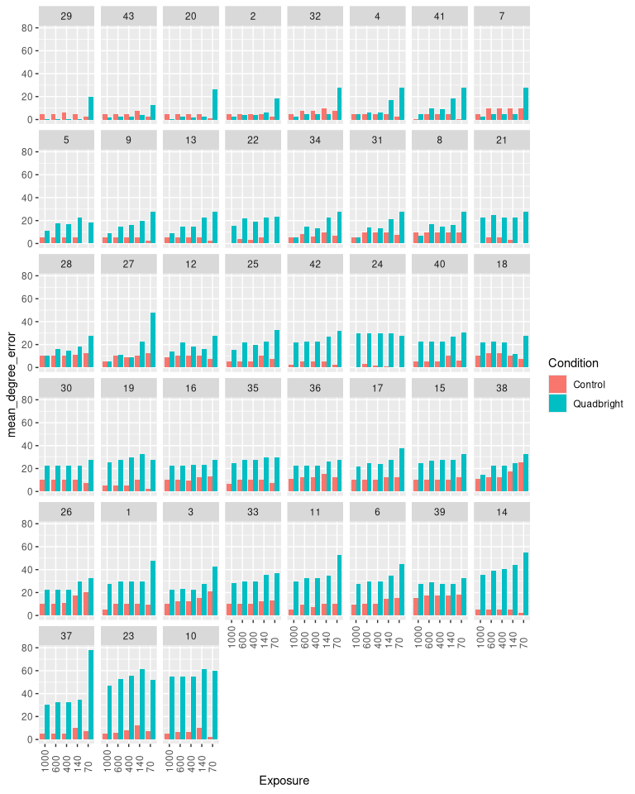
Figure 7
Figure Figure 7 shows the participant-level predicted values. The ability to read glance directions in the control condition is fairly consistent below 10° across participants and is virtually unaffected by exposure times. There is moderate variation in overall accuracy.
The disadvantage of Quadbright is fully consistent only at 70ms. In contrast, the ability to read Quadbright signals varies dramatically between participants and conditions. Even a group of super-performers exists (first six), where accuracy matches or even exceeds the control condition. This group is also characterized by an enormous difference between 70ms and 400ms, sometimes with an intermediate step at 140ms.
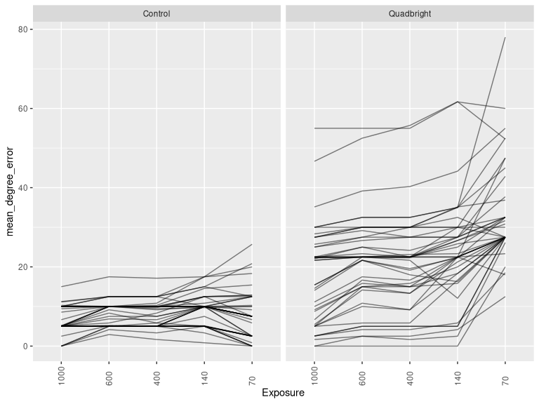
Figure 8

Discussion
The aim of the studies were to understand better how the signal-receiver system of glance direction reading in humans evolved. We approached this from two sides: First, we tested by construction of the Quadbright device how simple a receiver can be, which has consequences for how it co-evolved with sclera depigmentation. Second, we tested whether human observers possess a mininal receiver similar to Quadbright, or whether a more specialized mechanism exists.
The first study aimed at testing the signal efficiency of depigmented eyeballs, as this . The level of accuracy reached with a simple prototype was ample to provide selection pressure under the Cooperative Eye Hypothesis. We will discuss that in more detail.
The high accuracy even made us wonder whether the receiver in modern humans is similar to a Quadbright device, which gave rise to the second experiment. The results of the second experiment clearly show that this is not the case. Another receiver clearly exists, which is quite accurate, makes use of more advanced visual features, is extremely fast and varies little between participants. However, participants were still able to extract Quadbright glance directions at a lower accuracy most of the time. This mechanism requires longer exposure and varies dramatically between individuals.
For theory-forming an important issue to discuss is whether observations in the Quadbright condition justify to speak of a secondary receiver, which operates on brightness levels and could be the progenitor mechanism according to the Cue-before-signal principle.

The effective sender
The Cooperative Eye Theory implies that the eyeball is a very effective sender of glance direction signals for two reasons: first, sclera camouflage as a defensive feature can only stabilize as a new feature when there is a detection mechanism to protect against, which again implies a sender. Second, a receiver for cooperative means is more likely to pre-exist or co-evolve, when it is simple.
Overall, the Quadbright device showed good accuracy, in the same range as human observers (Gale & Monk, 2000). A linear decoder—mathematically equivalent to linear regression—operates in $O\left(d\right)$ parameter space and performs inference in $O\left(d\right)$ time, making it one of the simplest possible mappings from sensory input to behavioral output.
In contrast, signals whose discrimination requires multilayer, nonlinear decoders—such as those analogous to neural networks impose far greater metabolic, developmental, and evolutionary demands on receivers. This difference parallels well-established biological patterns: primitive photoreceptive organisms already exploit brightness gradients and coarse contrast edges as their primary visual features ((AnimalEyes?), ch. 2), whereas predators and prey locked in visual arms races often evolve complex, fractal, or high-spatial-frequency patterns that require increasingly sophisticated detection mechanisms ((Stevens2009?)).
It is important to note that the white sclera never evolved as a signal in vertebrates, but as a protection layer around the lense. Only, when the first vertebrates appeared on land, the sclera evolved into a ball, accommodating for the higher refractive index on the cornea-air surface (AnimalEyes?, ch. 9). The second defining feature, the dark iris and pupil have likewise evolved for biophysical reasons, as a variable aperture to adjust the incoming light intensity to the dynamic range of the retina (Kruijt et al., 2011).
Still, other features of the human eye morphology may have co-evolved with the receiver mechanism. From a computational perspective, it is surprising that the human eyeball produces highly linear gradients, as spinning spherical objects generally produce sinusoidal signals. It is possible that other features have evolved to improve the linearity of the response, such as the high ratio of exposed sclera (Kobayashi & Kohshima, 2001) or the shape of the eye lids. A testable consequence of this idea is that Quadbright devices are less effective for eye direction reading on other primate species, supposed they had a white sclera.

Evolution of the receving end
By construction we have shown that a simple linear decoder suffices to read glance directions from depigmented eyeballs with astonishing accuracy. This supports the idea that a primitive receiver could have existed prior to the evolution of white sclera. However, our results clearly show that human eyeball reading is is not a Quadbright device. A more complex receiver exists, which is extremely fast and accurate.
While most participants were less accurate with degraded images, the majority of the participants was still much beyond guessing. Importantly, in the Quadbright condition, the rigorous data compression forbids any more advanced receiver gradients to reliably process images. We can assume that performance in the Quadbright condition relies solely on brightness differences.
We can therefore conclude that a minimum of two receivers exist for eye direction reading. The first one is based on brightness gradients with moderate accuracy, and the second one extracts higher-level features for high accuracy. This idea is inline with a evolutionary process where a rudimentary cue receiver paves the way for the co-evolution of a signal and more advanced receiver. Usually, one would assume that the more advanced receiver evolves from primitive mechanism, effectively replacing it. Here it could be that the primitive receiver is still present, albeit with stark individual performance differences.
If the Quadbright receiver existed prior to the de-pigmentation event and was just acquiring another function, there is no reason it should vanish when being replaced by the follower. A stronger theory is that both receivers co-exist, as they provide different functions. This has previously been proposed by Anderson et al. (2016), who argue that there may be different mechanisms for precise gaze triangulation and coarse judgement of direction. By using a contrast reversal manipulation they showed that the first depends on geometric cues, whereas the second depends on luminance and motion cues.
[ventral vs dorsal processing]

Limitations

Future research
Speculating about how receiver mechanisms evolved, and how many there exist is fascinating, but more research needs to be conducted to make good for the fact that we cannot truly experiment with evolution in this case. Still, there are testable hypotheses that can be derived from the current results. In particular, we can make specific predictions about the alleged pregenitor receiver. It may have provided two fitness advantages: providing coarse direction signals in the peripheral field or over a distance, or signalling change of glance direction. Both capabilities can be tested experimentally.
Studying how eye direction cues establish shared attention also has impact in at least two modern fields of application. One open problem in transport is how automated vehicles can effectively communicate attention and intentions with human traffic members. For example, making eye contact is often observed in communication between drivers and street-crossing pedestrians. External human-machine interfaces (e-HMI) have been tested for communication on the outside of cars, using text, icons and facial expressions. Understanding the role and processing modes of eye direction reading can be used to design more efficient signals.
Another field of application is the design of artificial faces. In social robotics, robot faces are often designed to be expressive, and the role of glance reading in human-robot interaction is well established. However, designing more human-like eye regions for this purpose may result in an adverse effect known as the Uncanny Valley. Artificial faces that are too human-like, but not quite right, are perceived as creepy. The results of this study suggest that degraded eye regions can convey glance directions, which could facilitate the quality of interaction, without falling into the Uncanny Valley.
Finally, the eye tracker we build to test our ideas about the receiving end has already been used extensively for bachelor-level student projects. With some refinement it could deliver sufficient accuracy for many psychological experiments and applied research studies, with the added benefit of being much easier to replicate for everyone than with using commercial eye tracking devices.

Conclusion
The Cooperative Eye Hypothesis implies that eyes with a visible white sclera is sending exceptionally clear signals about gaze directions. While previous research made this assumption based on face validity, the successful implementation of the simplistic eye tracking algorithm supports this idea. By showing that humans can read glance directions under Quadbright conditions, but with reduced accuracy, lends support for multi-receiver theories, as well as the cue-before-signal theory of evolutionary origins.

References
Anderson, N. C., Risko, E. F., & Kingstone, A. (2016). Motion influences gaze direction discrimination and disambiguates contradictory luminance cues. Psychonomic Bulletin and Review, 23, 817–823. https://doi.org/10.3758/s13423-015-0971-8
Babinet, M.-N., Cublier, M., Demily, C., & Michael, G. A. (2021). Eye direction detection and perception as premises of a social brain: A narrative review of behavioral and neural data. Cognitive, Affective, &Amp; Behavioral Neuroscience, 22(1), 1–20. https://doi.org/10.3758/s13415-021-00959-w
Bakker, R., Wagstaff, E. L., Kruijt, C. C., Emri, E., Karnebeek, C. D. M. van, Hoffmann, M. B., Brooks, B. P., Boon, C. J. F., Montoliu, L., Genderen, M. M. van, & Bergen, A. A. (2022). The retinal pigmentation pathway in human albinism: Not so black and white. In Progress in Retinal and Eye Research (Vol. 91). Elsevier Ltd. https://doi.org/10.1016/j.preteyeres.2022.101091
Baron-Cohen, S. (1995). The eye detection detector (EDD) and the shared attention mechanism (SAM) : Two cases for evolutionary psychology. Joint Attention : Its Origin and Role in Development, 41–59. https://cir.nii.ac.jp/crid/1572261550899222144
Bender, F. R., & Schmettow, M. (2024). Evaluaton of the low budget do it yourself eye tracking system: Your eye tracker (YET) human factors and engineering psychology [PhD thesis, University of Twente]. https://purl.utwente.nl/essays/104538
Bradski, G. (2000). The OpenCV Library. Dr. Dobb’s Journal of Software Tools.
Bürkner, P.-C. (2018). Advanced Bayesian multilevel modeling with the R package brms. The R Journal, 10(1), 395–411. https://doi.org/10.32614/RJ-2018-017
Ciesla, M., & Koziol, P. (2012). Eye pupil location using webcam. Computer Vision and Pattern Recognition, 1–11.
Dessinioti, C., Stratigos, A. J., Rigopoulos, D., & Katsambas, A. D. (2009). A review of genetic disorders of hypopigmentation: Lessons learned from the biology of melanocytes. Experimental Dermatology, 18(9), 741–749. https://doi.org/10.1111/j.1600-0625.2009.00896.x
Farroni, T., Mansfield, E. M., Lai, C., & Johnson, M. H. (2003). Infants perceiving and acting on the eyes: Tests of an evolutionary hypothesis. Journal of Experimental Child Psychology, 85(3), 199–212. https://doi.org/10.1016/s0022-0965(03)00022-5
Farroni, T., Massaccesi, S., Menon, E., & Johnson, M. H. (2007). Direct gaze modulates face recognition in young infants. Cognition, 102(3), 396–404. https://doi.org/10.1016/j.cognition.2006.01.007
Farroni, T., Massaccesi, S., Pividori, D., & Johnson, M. H. (2004). Gaze following in newborns. Infancy, 5(1), 39–60. https://doi.org/10.1207/s15327078in0501_2
Gale, C., & Monk, A. F. (2000). Where am i looking? The accuracy of video-mediated gaze awareness. Perception & Psychophysics, 62, 586–595. https://doi.org/10.3758/BF03212110
Grønskov, K., Ek, J., & Brondum-Nielsen, K. (2007). Oculocutaneous albinism. Orphanet Journal of Rare Diseases, 2. https://doi.org/10.1186/1750-1172-2-43
Großerichter, J., & Schmettow, M. (2025). Human gaze estimation : Comparing accuracy in naturalistic and quad brightness conditions [Thesis, University of Twente].https://purl.utwente.nl/essays/106716
Guilford, T., & Dawkins, M. S. (1991). Receiver psychology and the evolution of animal signals. Animal Behaviour, 42, 1–14. https://doi.org/10.1016/S0003-3472(05)80600-1
Heck, M., Becker, C., & Deutscher, V. (2023). Webcam eye tracking for desktop and mobile devices: A systematic review. Proceedings of the 56th Hawaii International Conference on System Sciences. https://doi.org/10.24251/HICSS.2023.825
Hölter, J., & Schmettow, M. (2025). How do humans perceive gaze direction [Thesis, University of Twente].https://purl.utwente.nl/essays/107106
Kobayashi, H., & Kohshima, S. (2001). Unique morphology of the human eye and its adaptive meaning: Comparative studies on external morphology of the primate eye. Journal of Human Evolution, 40(5), 419–435. https://doi.org/10.1006/jhev.2001.0468
Krafka, K., Khosla, A., Kellnhofer, P., Kannan, H., Bhandarkar, S., Matusik, W., & Torralba, A. (2016). Eye tracking for everyone. IEEE Conference on Computer Vision and Pattern Recognition (CVPR). http://gazecapture.csail.mit.edu.
Kruijt, B., Franssen, L., Prick, L. J. J. M., Vliet, J. M. J. van, & Berg, T. J. T. P. van den. (2011). Ocular straylight in albinism. Optometry and Vision Science, 88, E585–E592. https://doi.org/10.1097/OPX.0b013e318212071e
Laidre, M. E., & Johnstone, R. A. (2013). Animal signals. Current Biology, 23, R829–R833. https://doi.org/10.1016/j.cub.2013.07.070
Loomis, J. M., Kelly, J. W., Pusch, M., Bailenson, J. N., & Beall, A. C. (2008). Psychophysics of perceiving eye-gaze and head direction with peripheral vision: Implications for the dynamics of eye-gaze behavior. Perception, 37(9), 1443–1457. https://doi.org/10.1068/p5896
Mayhew, J. A., & Gómez, J. (2015). Gorillas with white sclera: A naturally occurring variation in a morphological trait linked to social cognitive functions. American Journal of Primatology, 77(8), 869–877. https://doi.org/10.1002/ajp.22411
Mearing, A. S., Burkart, J. M., Dunn, J., Street, S. E., & Koops, K. (2022). The evolutionary drivers of primate scleral coloration. Scientific Reports, 12(1). https://doi.org/10.1038/s41598-022-18275-9
Pastel, S., Chen, C. H., Martin, L., Naujoks, M., Petri, K., & Witte, K. (2021). Comparison of gaze accuracy and precision in real-world and virtual reality. Virtual Reality, 25, 175–189. https://doi.org/10.1007/s10055-020-00449-3
Pedregosa, F., Varoquaux, G., Gramfort, A., Michel, V., Thirion, B., Grisel, O., Blondel, M., Prettenhofer, P., Weiss, R., Dubourg, V., Vanderplas, J., Passos, A., Cournapeau, D., Brucher, M., Perrot, M., & Duchesnay, E. (2011). Scikit-learn: Machine learning in Python. Journal of Machine Learning Research, 12, 2825–2830.
R Core Team. (2025). R: A language and environment for statistical computing. R Foundation for Statistical Computing. https://www.R-project.org/
Singh, H., & Singh, J. (2012). Human eye tracking and related issues: A review. International Journal of Scientific and Research Publications, 2. www.ijsrp.org
Tomasello, M., Hare, B., Lehmann, H., & Call, J. (2007). Reliance on head versus eyes in the gaze following of great apes and human infants: The cooperative eye hypothesis. Journal of Human Evolution, 52, 314–320. https://doi.org/10.1016/j.jhevol.2006.10.001
Wolf, W., Thielhelm, J., & Tomasello, M. (2022). Five-year-old children show cooperative preferences for faces with white sclera. Journal of Experimental Child Psychology, 225, 105532. https://doi.org/10.1016/j.jecp.2022.105532
Yorzinski, J. L., Thorstenson, C. A., & Nguyen, T. P. (2021). Sclera and iris color interact to influence gaze perception. Frontiers in Psychology, 12. https://doi.org/10.3389/fpsyg.2021.632616
Zhou, Z.-H., & Geng, X. (2004). Projection functions for eye detection. Pattern Recognition, 37, 1049–1056. https://doi.org/10.1016/j.patcog.2003.09.006

